
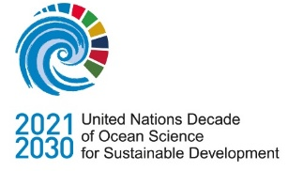
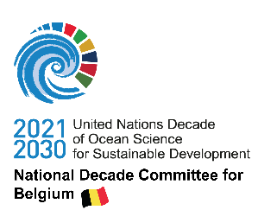
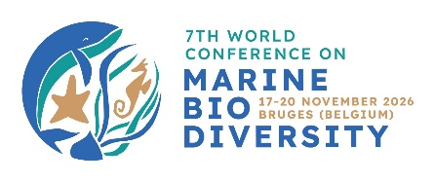

APPLICATION FORM
Full Package Participation Grant for WCMB

The 7th World Conference on Marine Biodiversity
The WCMB participation grants are funded by The Sea as a Good Cause, and The secretariat of the National Decade Committee (NDC) for Belgium.
Application for the full package participation grant for ‘The 7th World Conference on Marine Biodiversity’ is only valid if the following documents are submitted by email to filantropie@vliz.be no later than 17 March 2026. Use the subject line ‘Motivation letter – full package participation grant – WCMB’.
☐ This application form (fully completed, max. 3 pages)
☐ Your abstract for submission. Did you submit your abstract through the online WCMB form, yes/no?
☐ Your curriculum vitae
☐ A consent letter of your supervisor (free format)
☐ A copy of your bachelor/master’s degree or prove of your doctoral grant

Will you need a visa to travel to Belgium yes/no?
Conference participants requiring a Schengen Visa to enter the EU are responsible for obtaining this well in advance before travel. Please see Schengen visa requirements.

Do you apply as an ECOP?
☐ from the Global South active in a country listed on Annex 1
☐ from a marine research institute linked to VLIZ by its international collaboration agreement listed in Annex 2
☐ as a WoRMS editor from the Global South active in a country listed on Annex 1

General information
Name of the applicant
Date of birth of the applicant
University or research institute you are affiliated to
Are you a bachelor, master, a PhD student or a junior postdoc?
Title of the bachelor/ master/ PhD/ postdoc research
Name of your supervisor/promotor
University or research institute your supervisor is affiliated to
Title of the abstract that you submitted for WCMB
Do you aim for a poster or an oral presentation?

Motivation for participation at the WCMB
Motivate why participation at ‘The 7th World Conference on Marine Biodiversity’ is an added value to your scientific career.
max. 3500 characters including spaces

Abstract submission
Candidates for the participation grant for ‘The 7th World Conference on Marine Biodiversity’ are required to be prepared to present their work on stage or as a poster. As part of the selection process, acceptance of an abstract is mandatory. The abstract will be carefully reviewed as part of the selection procedure. This abstract is the same as the one you submitted on the WCMB form.
The abstract includes a title, a body text of 250-350 words, plus 5 to 7 keywords.

